June 10th, 2012
Hi
HAPPY BIRTHDAY NADINE

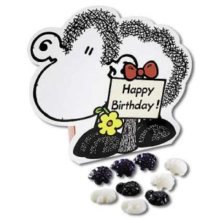
Happy birthday for Tuesday. Take your choice of birthday cards.


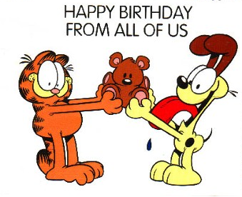

I will try to be quicker with this letter as the publisher for one of the books is screaming out for the last batch of work to be sent in as they have to set it all up and then meet with the Education Department on Wednesday! I was working all day yesterday and will probably have to do the same today.
We have been getting some very hot weather recently. One of the first things I now check on the Internet when I turn on the computer in the mornings, along with e-mail sites, is the current temperature. The observatory website includes a map with the temperatures at different places displayed. The area around here is often among the hottest parts on HK, and conversely one of the coolest in winter. While living in the hotel, I seldom viewed this part of the website as with all-year-round air-conditioning temperatures were never extreme.
Last weekend and Monday, the swimming pool was closed part of the time. This was due to a lot of sand in it that had blown in from somewhere, and had to be removed. Another five swims this past week for a total of 10.2 km.
The annual June 4 candlelight vigil was held last Monday evening. There were about 190 000 participants according to the organisers, with many being young people from China who know little about what happened in 1989. In China, the authorities were very busy blocking any websites that had anything to do with June 4. At times this reached ludicrous extremes. For example, all access to websites for the Shanghai Stock Exchange were blocked because the index for that day fell 64.89 points. Get it? (6-4-'89 or June 4, 1989)
In last week's letter, I asked whether Tom's recent graduation was his first or second. Nobody told me but I now realise it must be the second. When I was downloading photos that Leonie sent for the latest graduation, I saw there was file for a graduation two years ago. However, there were no actual pictures of his graduation; they were all related to Kaia. So I assume that was for his MD if my guess that the recent one was the PhD is correct. Also, only Gavin picked up (or at least let me know) that I was a month out in my dates - it should have been July 4th and not June 4th. I actually realised this myself after sending the letter, when I was reading Time and July 4th came up in some article.
That's about it. Now to work!
Cheers

